**Software Design Document**

\

**For**

**KISAN APP**

**Version-1.0**

**Table of Contents**

1.0 Introduction 3

1.1 Project 3

1.2 Scope 3

1.3 Technologies Used 3

1.3.1 React Native (version 0.64.2) 3

1.3.2 Node.js (version 14.17.3) 4

1.3.3 JDK (version 8 or above) 4

1.3.4 Android Studio (version 4.2.2) 4

1.3.5 PostgreSQL (version 13.4.2) 4

1.3.6 pgAdmin 5

1.3.7 PHP (version 8.0.9) 5

1.3.8 XAMPP Server (version 3.3.0) 5

1.3.9 phppgadmin (version 7.13.0) 5

2.0 Functional Requirement 6

2.1 Use Cases 6

2.2 Use Case Diagram 12

3.0 Data Description 13

3.1 Data Flow Diagram 13

3.2 Flow Charts 14

3.3 Database Description 15

3.3.1 Table ‘users’ 15

3.3.2 Table ‘loc_table’ 15

3.3.3 Table ‘weather’ 16

3.3.4 Table ‘agro_advisory’ 17

3.3.5 Table ‘feedback’ 18

4.0 User Manual 20

4.1 Language Selection Screen 20

4.2 Welcome Screen 20

4.3 Register Screen 22

4.4 Log In Screen 23

4.5 Home Screen 24

4.6 Bottom Tabs for Navigation 26

4.7 Advisory Screen 27

4.8 Feedback Form 29

4.9 Links Screen 31

4.10 Sidebar Navigation 31

4.11 Profile 32

5.0 Definitions and Acronyms 33

6.0 References 34

# Introduction

## Project

**KISAN** is an app for **KISAN** **E***mpowerment* through **S***atellite-based* **A***gricultural* **A***dvisory* and **N***owcast*. This application provides weather forecasts and advisory for crops and weather to the farmers of India based on their location, according to the data obtained from meteorological satellites. The app is available in two languages - English and Hindi.

## Scope

Farming is a big financial investment and involves a lot of effort. By raising crops, farmers not only serve the country but also support their families. Therefore, getting a proper return on their investment is vital for the farmers to continue farming. With the drastic changes in weather and the ever-increasing global warming, the seasonal rhythm has been disturbed and the weather has become unpredictable. A sudden rain, for example, can cause huge damage to the crops, causing both economic and mental discomfort to the farmers. Over the past years, the number of farmers committing suicide from depression has risen.

To help the farmers in growing the right crops and successfully harvesting them, a resource that provides advisory regarding specific crops is essential. This would greatly enhance the utility of weather forecasts. Such a platform will help the farmers in doing profitable farming.

## Technologies Used

### [React Native](https://reactnative.dev/) (version 0.64.2)

React Native is a JavaScript framework used for developing a real, native mobile application for iOS and Android. It uses only JavaScript to build a mobile application. It is like React, which uses native components rather than using web components as building blocks. React Native apps are not web applications. They are running on a mobile device, and it does not load over the browser. React Native apps are the real native app, the JavaScript code stays as JavaScript, and they run in some extra thread by the compiled app. The user interface and everything is compiled to native code.

The entire KISAN application is written in react native.

### [Node.js](https://nodejs.org/en/) (version 14.17.3)

Node.js is an open-source, cross-platform, back-end JavaScript runtime environment that runs on the V8 engine and executes JavaScript code outside a web browser. It is designed to build scalable network applications.

The app requires NPM (version 6.14.14) for installing the dependencies.

## 

### [JDK](https://openjdk.java.net/projects/jdk8/) (version 8 or above)

JDK is required for developing apps using React Native CLI.

## 

### [Android Studio](https://developer.android.com/studio/) (version 4.2.2)

Android Studio is the official integrated development environment (IDE) for Google's Android operating system, designed specifically for Android development.

It also provides an emulator (a virtual device) on which the app can be run, thus helping in debugging.

## 

### [PostgreSQL](https://www.postgresql.org/) (version 13.4.2)

PostgreSQL is a free and open-source relational database management system (RDBMS) emphasizing extensibility and SQL compliance.

This app uses PostgreSQL database to store user information, weather forecast & agricultural advisory based on location and date, user feedback for a bulletin, and the available locations.

### pgAdmin

pgAdmin is a GUI for interacting with the PostgreSQL database.

## 

### [PHP](https://www.php.net/) (version 8.0.9)

PHP is a general-purpose scripting language geared towards web development. PHP code is usually processed on a web server by a PHP interpreter implemented as a module, a daemon, or as a Common Gateway Interface (CGI) executable. On a web server, the result of the interpreted and executed PHP code forms the whole or part of an HTTP response.

PHP is used for connecting the react-native frontend with the PostgreSQL database of the app.

## 

### [XAMPP Server](https://www.apachefriends.org/download.html) (version 3.3.0)

XAMPP is a free and open-source cross-platform web server solution stack package developed by Apache Friends, consisting mainly of the Apache HTTP Server, MariaDB database, and interpreters for scripts written in the PHP and Perl programming languages. Since most actual web server deployments use the same components as XAMPP, it makes transitioning from a local test server to a live server possible.

## 

### [phppgadmin](https://github.com/phppgadmin/phppgadmin) (version 7.13.0)

phpPgAdmin is a fully functional web-based administration utility for a PostgreSQL database server. It handles all the basic functionality as well as some advanced features such as triggers, views, and functions (stored procs). The administrator can fully interact with the database here.

# Functional Requirement

## Use Cases

|  |  |  |
| --- | --- | --- |
| **Use Case 0: LANGUAGE SELECTION** | | |
| * Actors | : | User |
| * Type | : | Primary and Essential |
| * Pre-condition | : | None |
| * Main Case Scenario | : | * User selects the preferred language for the application (English or Hindi). |
| * Exception Scenario | : | None |

|  |  |  |
| --- | --- | --- |
| **Use Case 1: REGISTER** | | |
| * Actors | : | User |
| * Type | : | Primary and Essential |
| * Pre-condition | : | None |
| * Main Case Scenario | : | * User enters personal information (name, mobile number, state, district, block, etc) to create a new account. * On submitting, the system creates a user account and stores the required information into the database. |
| * Exception Scenario | : | * User inputs a mobile number containing less than 10 digits. The user is requested to provide the correct information to create an account. * User leaves either of the necessary fields - name, mobile number, state, district, or block - empty. The user is requested to provide all the details to create an account. * The system is unable to connect to the database. ‘Server Error’ message is displayed and the user is requested to try again. |

|  |  |  |
| --- | --- | --- |
| **Use Case 2: LOG IN** | | |
| * Actors | : | User |
| * Type | : | Primary and Essential |
| * Pre-condition | : | User already has an account registered by their mobile number |
| * Main Case Scenario | : | * User enters the registered mobile number to log into the account. * System checks for an account with the provided mobile number in the database and fetches the account details. * User successfully logs into their account. |
| * Exception Scenario | : | * The mobile number entered contains less than 10 digits. The user is requested to enter the correct mobile number. * No account exists with the entered mobile number. The user is requested to create a new account. * The system is unable to connect to the database. ‘Server Error’ message is displayed and the user is requested to try again. |

|  |  |  |
| --- | --- | --- |
| **Use Case 3: PROFILE** | | |
| * Actors | : | System |
| * Type | : | Primary and Essential |
| * Pre-condition | : | User has already logged into their account. |
| * Main Case Scenario | : | * System fetches user information from the database and displays it to the user. |
| * Exception Scenario | : | * The system is unable to connect to the database. ‘Server Error’ message is displayed and the user is requested to try again. |

|  |  |  |
| --- | --- | --- |
| **Use Case 4: WEATHER FORECAST** | | |
| * Actors | : | Administrator, System |
| * Type | : | Primary and Essential |
| * Pre-condition | : | User has already logged into their account. |
| * Main Case Scenario | : | * The administrator enters the weather forecast details (rain, wind, humidity, current temperature, maximum and minimum temperature, weather type, etc) for all locations (according to date) into the database. * The system fetches the weather forecast of today (for the user's location) and displays it to the user. * The system is unable to connect to the database. ‘Server Error’ message is displayed and the user is requested to reload (or try again). |
| * Exception Scenario | : | * Complete or part of the weather forecast for the given location or the given date is not provided by the administrator. Nothing is displayed for the missing part. |

|  |  |  |
| --- | --- | --- |
| **Use Case 5: AGRO- ADVISORY** | | |
| * Actors | : | Administrator, System |
| * Type | : | Primary and Essential |
| * Pre-condition | : | User has already logged into their account. |
| * Main Case Scenario | : | * The administrator enters the advisory details (weather advisory, advisory for rice, fodder, sugarcane, vegetables, cattle, and general advisory, etc) for all locations (according to date) into the database. * The system fetches the advisory for today (for the user's location), in the user’s preferred language, and displays it to the user. |
| * Exception Scenario | : | * The advisory for a given crop/weather is not available in the user’s preferred language. System displays the advisory for the corresponding crop/weather in the other language. * The advisory for a given crop/weather is not available in any language. System doesn’t display a separate tab for the advisory of the corresponding crop/weather. * No advisory is available for the given place or given location. Nothing is displayed to the user. * The system is unable to connect to the database. ‘Server Error’ message is displayed and the user is requested to reload (or try again). |

|  |  |  |
| --- | --- | --- |
| **Use Case 6: FEEDBACK FORM** | | |
| * Actors | : | User |
| * Type | : | Primary and Essential |
| * Pre-condition | : | User has already logged into their account. |
| * Main Case Scenario | : | * User provides feedback for the weather forecast and agro-advisory bulletins of any date. * On submitting, the feedback provided by the user is stored in the database. |
| * Exception Scenario | : | * User doesn’t fill the entire form. The user is requested to fill the entire form to submit their feedback. * The system is unable to connect to the database. ‘Server Error’ message is displayed and the user is requested to try again. |

|  |  |  |
| --- | --- | --- |
| **Use Case 7: USEFUL LINKS** | | |
| * Actors | : | System |
| * Type | : | Primary and Essential |
| * Pre-condition | : | User has already logged into their account. |
| * Main Case Scenario | : | * System displays some useful links related to weather forecasts and agro-advisory. |
| * Exception Scenario | : | None |

|  |  |  |
| --- | --- | --- |
| **Use Case 8: LOG OUT** | | |
| * Actors | : | User |
| * Type | : | Primary and Essential |
| * Pre-condition | : | User has already logged into their account. |
| * Main Case Scenario | : | * User logs out of their account. * The system successfully returns to the welcome page. |
| * Exception Scenario | : | None |

## Use Case Diagram

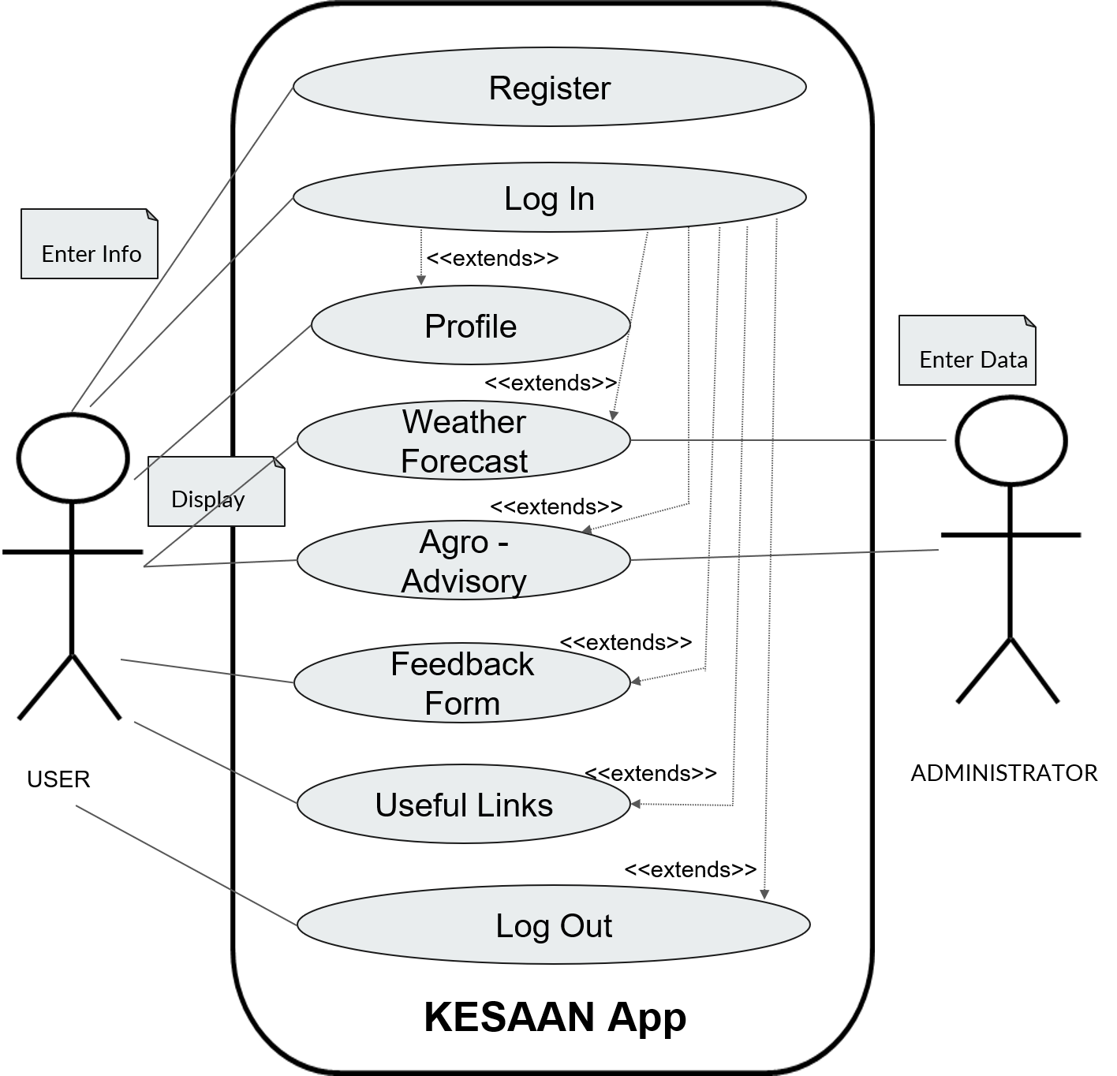

# Data Description

## Data Flow Diagram

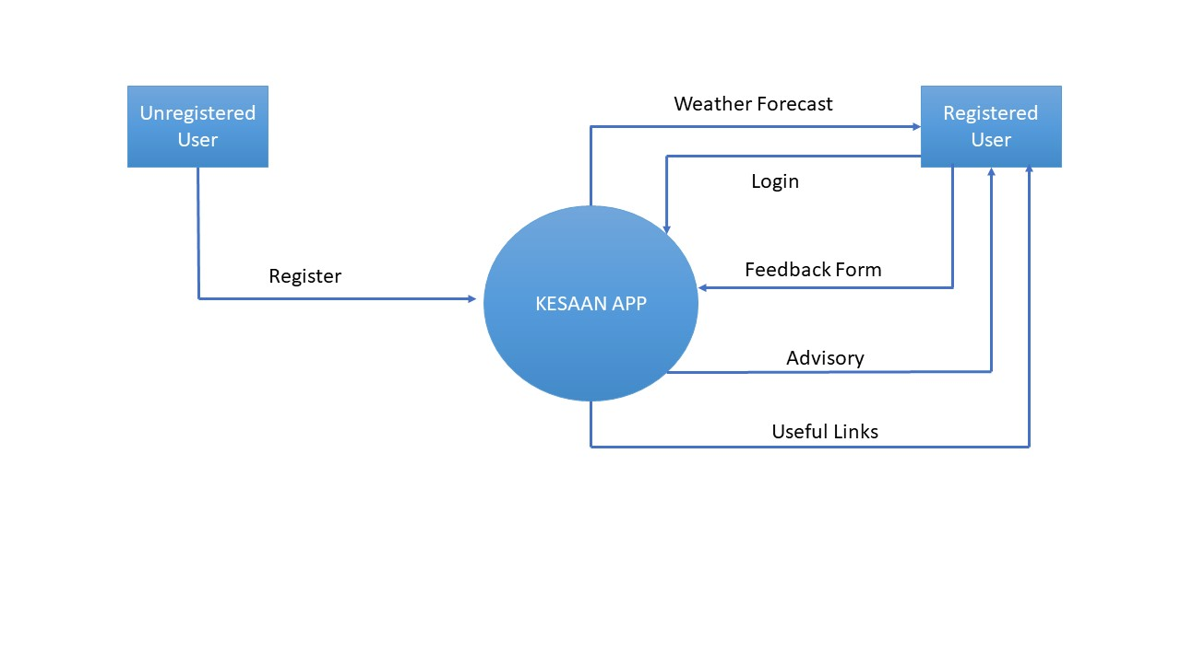

* + 1. **Level - 0 Data Flow Diagram**

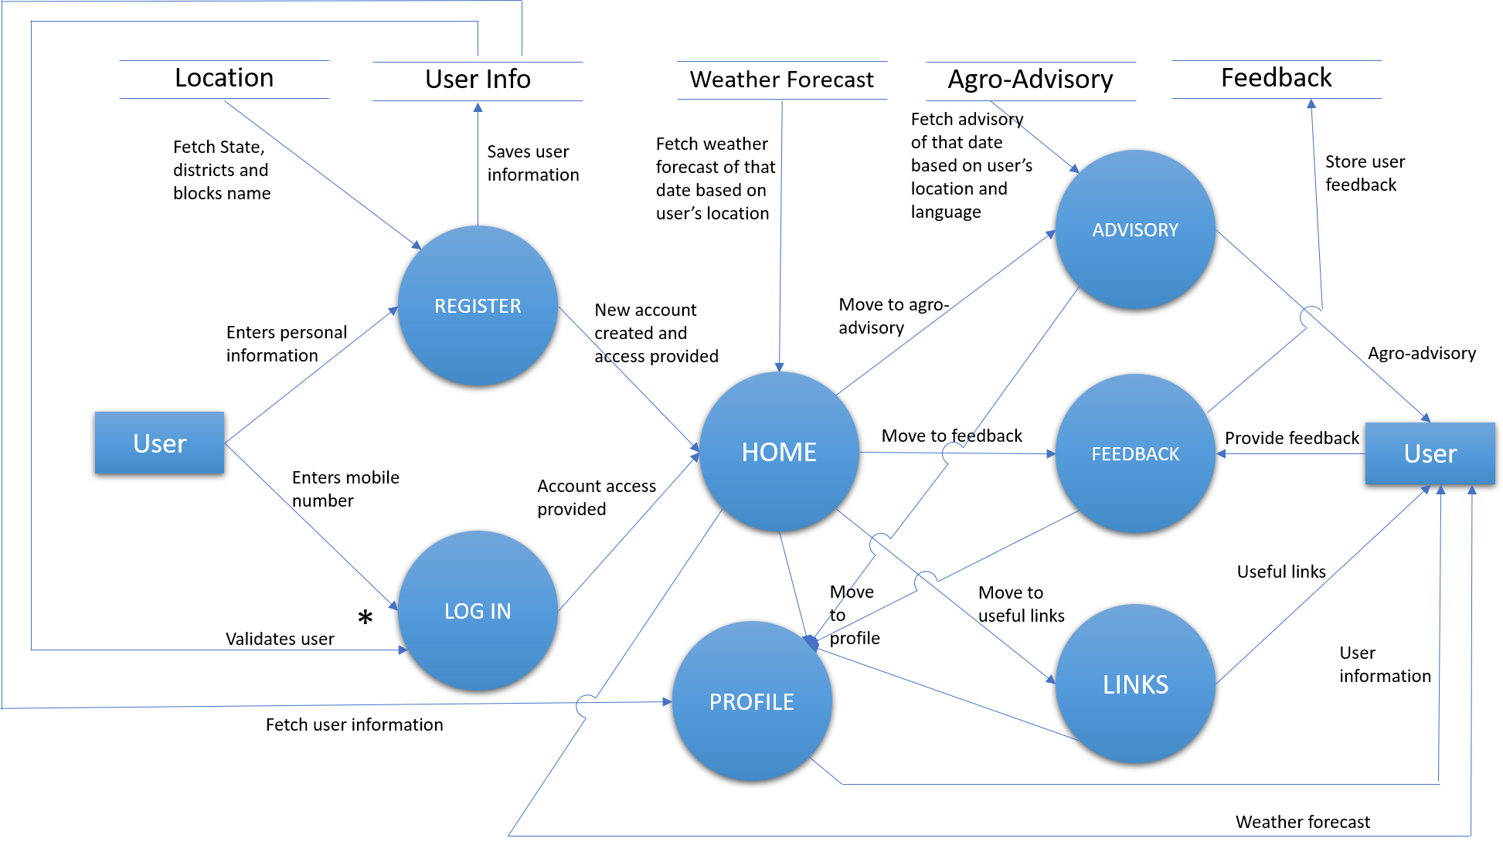

* + 1. **Level - 1 Data Flow Diagram**

## Flow Charts

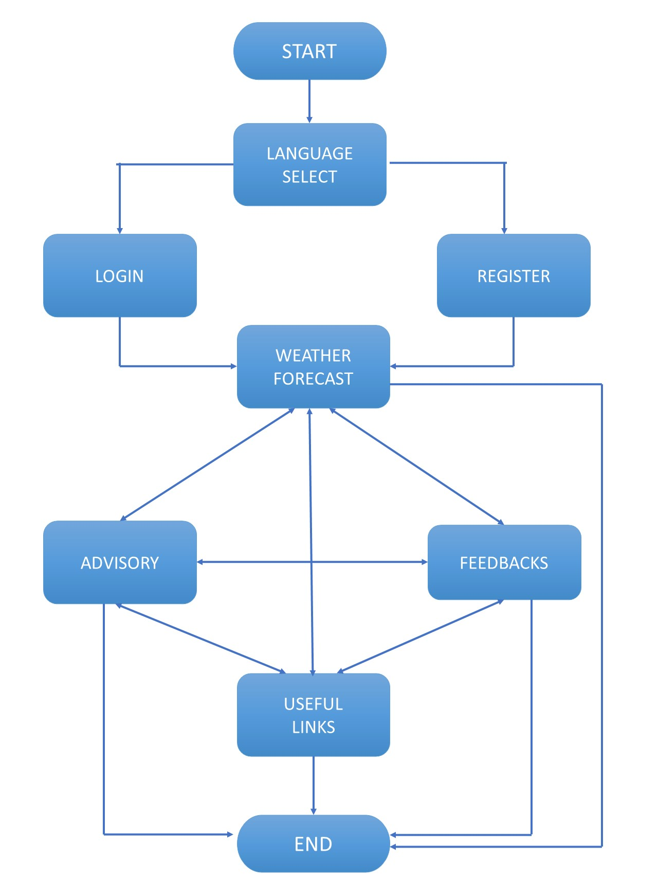

## Database Description

### Table ‘users’

The table contains the information of the users registered in the app.

|  |  |  |
| --- | --- | --- |
| **Field Name** | **Data Type** | **Description** |
| id | Serial | Gives a serial number and is the primary key of the table. |
| location_id | Integer | Stores location id of the user. |
| sel_lang | VARCHAR(10) | Stores the selected language of the user. |
| user_name | VARCHAR(40) | Stores the name of the user. |
| user_mobile | VARCHAR(10) | Stores the mobile number of the user. |
| mob_imei_no | VARCHAR(15) | Stores the IMEI number of the mobile of the user. |
| mob_model | VARCHAR(30) | Stores the model name of mobile. |
| mob_os | VARCHAR(20) | Stores the operating system name of the mobile. |
| os_version | VARCHAR(5) | Stores the version of the operating system of mobile. |
| registered_on | timestamp (without time zone) | Stores the registration time of the user. |

### Table ‘loc_table’

The table contains the information of different locations consists of – STATE, DISTRICT, and BLOCK.

|  |  |  |
| --- | --- | --- |
| **Field Name** | **Data Type** | **Description** |
| id | Serial | Gives a serial number and is the primary key of the table. |
| state_code | Integer | Stores code of the state. It is unique for each state. |
| state_name | VARCHAR(30) | Stores name of the state. |
| district_code | Integer | Stores code of the district. This code is unique for each district of a particular state, but may repeat for districts of another state. |
| district_name | VARCHAR(30) | Stores name of the district. |
| block_code | Integer | Stores code of the block. It is unique for each block of a particular district. |
| block_name | VARCHAR(30) | Stores name of the block. |
| village_code | Integer | Stores code of the village. It is unique for each village of a particular block, |
| village_name | VARCHAR(30) | Stores name of the village. |

### Table ‘weather’

The table contains the information on weather conditions of different locations.

|  |  |  |
| --- | --- | --- |
| **Field Name** | **Data Type** | **Description** |
| id | Serial | Gives a serial number and is the primary key of the table. |
| location_id | Integer | Stores location id of a block. |
| cur_temp | Integer | Stores current temperature of the location. |
| max_temp | Integer | Stores maximum temperature of the location. |
| min_temp | Integer | Stores minimum temperature of the location. |
| rain | Integer | Stores rain percentage of the location. |
| humidity | Integer | Stores humidity percentage of the location. |
| wind | Integer | Stores speed of wind of the location. |
| weather_date | Date | Stores the date of the weather forecast. |
| weather_type | VARCHAR(10) | Stores the weather type of the area on that day  (eg - Rainy, Sunny, Cloudy, etc.) |

### Table ‘agro_advisory’

The table contains the information of agriculture advisory of different locations.

|  |  |  |
| --- | --- | --- |
| **Field Name** | **Data Type** | **Description** |
| id | Serial | Gives a serial number and is the primary key of the table. |
| location_id | Integer | Stores the location id of the location corresponding to the advisory. |
| adv_date | Date | Stores the date of the advisory. |
| adv_weather_en | VARCHAR(1000) | Stores weather advisory in the English language. |
| adv_rice_en | VARCHAR(1000) | Stores rice advisory in the English language. |
| adv_fodder_en | VARCHAR(1000) | Stores fodder advisory in the English language. |
| adv_sugarcane_en | VARCHAR(1000) | Stores sugarcane advisory in the English language. |
| adv_vegetables_en | VARCHAR(1000) | Stores vegetable advisory in the English language. |
| adv_cattle_en | VARCHAR(1000) | Stores cattle advisory in the English language. |
| adv_gen_en | VARCHAR(1000) | Stores general advisory in the English language. |
| adv_weather_hi | VARCHAR(1000) | Stores weather advisory in the Hindi language. |
| adv_rice_hi | VARCHAR(1000) | Stores rice advisory in the Hindi language. |
| adv_fodder_hi | VARCHAR(1000) | Stores fodder advisory in the Hindi language. |
| adv_sugarcane_hi | VARCHAR(1000) | Stores sugarcane advisory in the Hindi language. |
| adv_vegetables_hi | VARCHAR(1000) | Stores vegetable advisory in the Hindi language. |
| adv_cattle_hi | VARCHAR(1000) | Stores cattle advisory in the Hindi language. |
| adv_gen_hi | VARCHAR(1000) | Stores general advisory in the Hindi language. |

### Table ‘feedback’

The table contains the feedback of the user.

|  |  |  |
| --- | --- | --- |
| **Field Name** | **Data Type** | **Description** |
| id | Serial | Gives a serial number and is the primary key of the table. |
| location_id | Integer | Stores location id of the user. |
| farmer_name | VARCHAR(40) | Stores name of the user. |
| state_name | VARCHAR(30) | Stores name of the state of the user. |
| district_name | VARCHAR(30) | Stores name of the district of the user. |
| block_name | VARCHAR(30) | Stores name of the block of the user. |
| mobile_num | VARCHAR(10) | Stores the mobile number of the user. |
| age | Integer | Stores age of the user. |
| gender | VARCHAR(1) | Stores gender of the user. |
| education | VARCHAR(50) | Stores education of the user. |
| landholding_type | VARCHAR(50) | Stores type of landholding. |
| farming_type | VARCHAR(50) | Stores type of farming. |
| landholding_area | VARCHAR(30) | Stores area of landholding. |
| wheat_area | VARCHAR(30) | Stores area of wheat. |
| rice_area | VARCHAR(30) | Stores area of rice. |
| sugarcane_area | VARCHAR(30) | Stores area of sugarcane. |
| mustard_area | VARCHAR(30) | Stores area of mustard. |
| maize_area | VARCHAR(30) | Stores area of maize. |
| potato_area | VARCHAR(30) | Stores area of potato. |
| fodder_area | VARCHAR(30) | Stores area of fodder. |
| vegetable_area | VARCHAR(30) | Stores area of vegetables. |
| animal_husbandry | VARCHAR(100) | Stores animal husbandry. |
| poultry_farming | VARCHAR(4) | Stores whether or not involved in poultry farming. |
| fish_farming | VARCHAR(4) | Stores whether or not involved in fish farming. |
| horticultural_crops | VARCHAR(100) | Stores horticultural crops grown. |
| bulletin-received | VARCHAR(4) | Stores the status of receiving the bi-weekly Forecast and Advisory bulletins regularly. |
| sources | VARCHAR(300) | Stores sources of Weather forecasts and Advisory. |
| bulletin_timely_issued | VARCHAR(4) | Stores the status of timely receiving of Weather forecast and Advisory bulletin. |
| feedback_bulletin_date | Date | Stores the issue date for the bulletin for which feedback is being given. |
| bulletin_useful | VARCHAR(4) | Stores the status of the usefulness of bulletin in agricultural operations. |
| bulletin_not_useful | VARCHAR(100) | Stores the reason why the bulletin was not useful. |
| advice_not_useful | VARCHAR(100) | Stores the reason why the advice was not useful. |
| useful_agri_operations | VARCHAR(300) | Stores the agricultural operations for which bulletin was useful. |
| other_info_req | VARCHAR(100) | Stores the user feedback about additional information to be stored in the KISAN Advisory bulletin. |
| how_much_useful | VARCHAR(100) | Stores user feedback about how KISAN Advisory bulletin helps in farm operations. |
| shared_w_others | VARCHAR(4) | Stores the status of sharing the weather forecast with other farmers. |
| economic_benefits | VARCHAR(50) | Stores user feedback about economic benefits of advisory bulletins in agricultural operations in a season. |
| avg_production_lost | VARCHAR(50) | Stores average percentage of production lost during the crop season due to bad weather. |
| ratings | Integer NOT null | Stores ratings of the KISAN app. |
| farmer_email | VARCHAR(50) | Stores farmer’s email. |
| submitted_on | timestamp | Stores the time and date of submission of feedback form. |

# User Manual

## Language Selection Screen

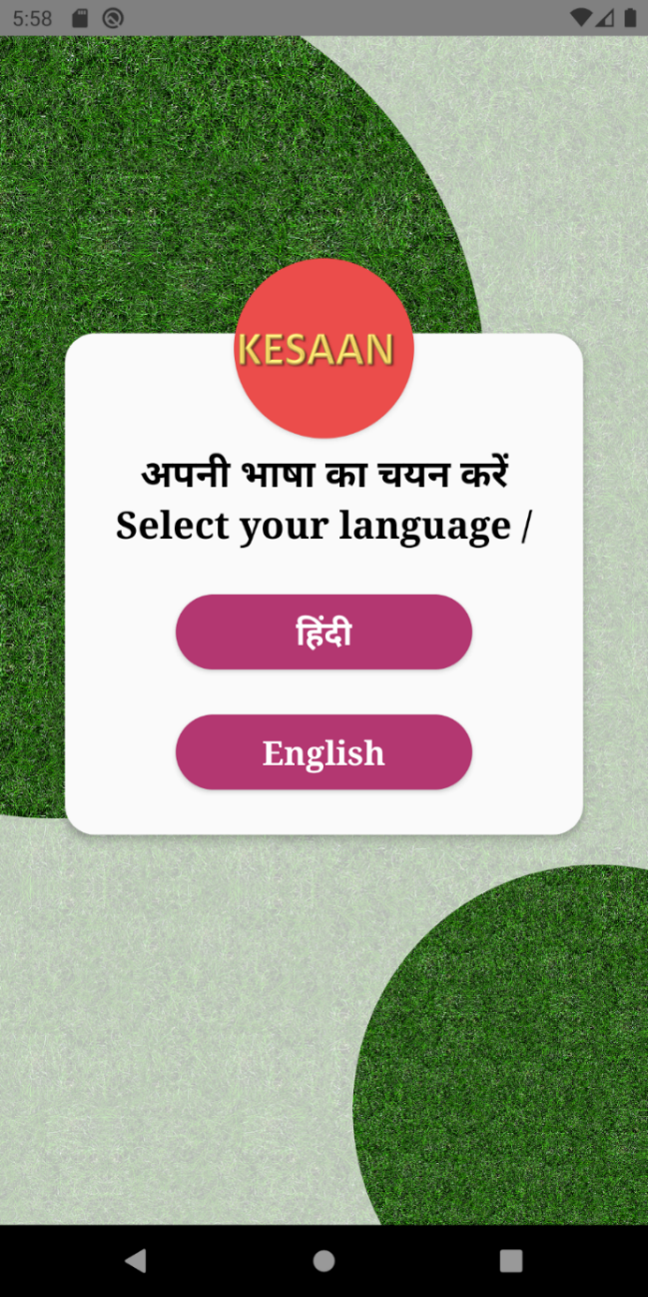

When KESAAN mobile application is downloaded and opened for the first time, Language Selection window is displayed as shown in the image.

User must select their preferred language for the application - ENGLISH OR हिंदी.

This will change the language of application interface to that selected by the user.

## Welcome Screen

Welcome screen will be displayed in the language selected by the user. Following are the demo screens for English and Hindi language respectively.

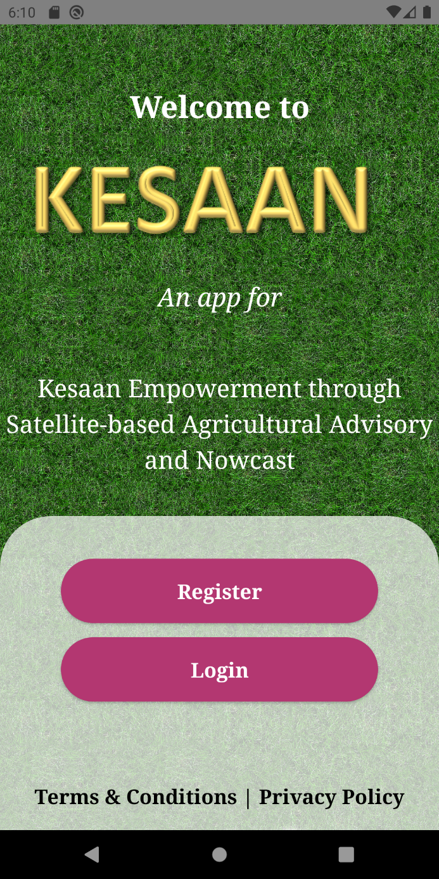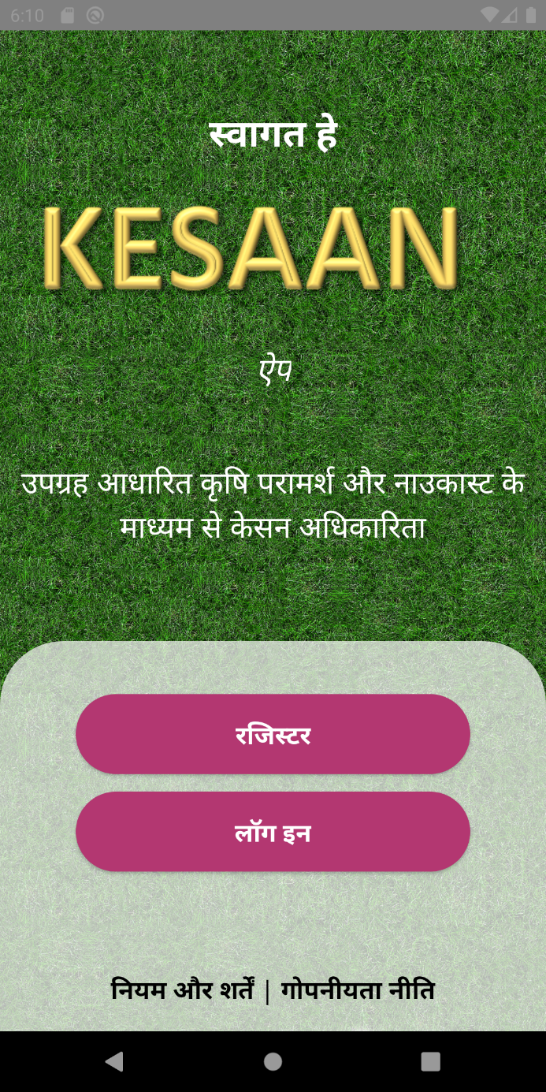

**Welcome Screen of the app in English**

**Welcome Screen of the app in Hindi**

The screen contains two buttons:

1. Register (For new users) - New users may create their account
2. Log In (For registered users) – Existing users can log into their account
3. At the bottom of the screen, links to Terms and Conditions and Privacy Policy are given.

## Register Screen

This contains the user registration form. New users may fill in their details – preferred language, name, mobile number, location (state, district, block) – to create their account.

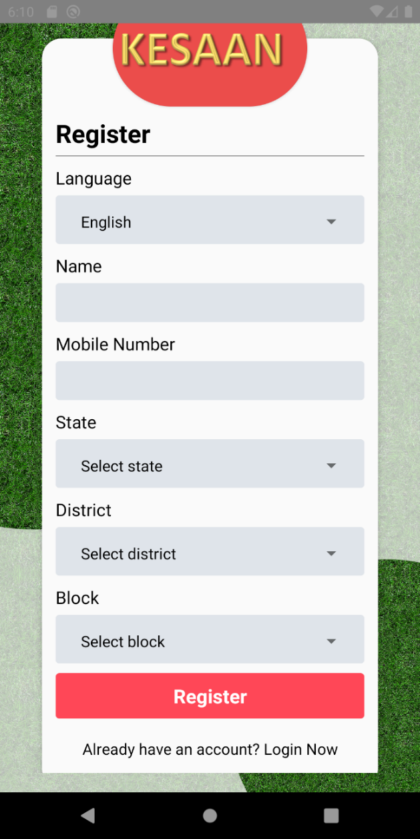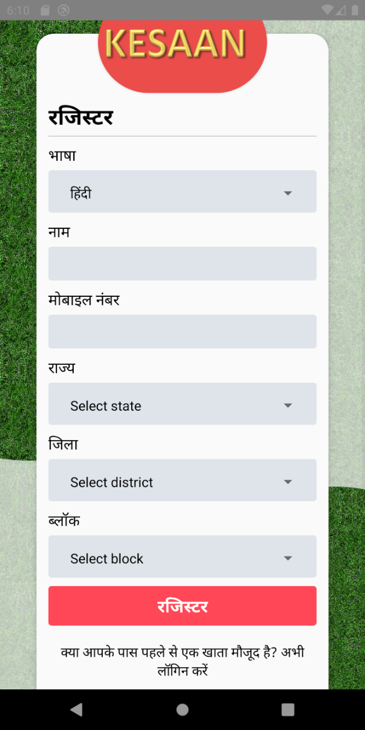

The language field will display the language chosen by the user initially, but the user has the option to change it. The user name field accepts only alphabets and ‘'’ symbol. No number and any other symbol is acceptable.

***Please check the form again before submitting, as nothing can be done afterwards.***

However, if a user enters incorrect data (like mobile number having less than 10 digits) or any of the fields is left blank, the same will be notified and registration will be aborted.

Successful registration will display the message “Successfully registered” and user will be logged into their account.

If user has an existing account and they try to register, a warning message will be displayed and registration will be aborted. They may go to the Log In page from the link at the bottom of the screen.

## Log In Screen

The Login Screen will be displayed according to the language preference of the user.

The user should enter their registered mobile number (containing 10 digits) to successfully log into their account.

If the mobile number is not registered, a warning message will be prompted and the user may register from the link given below the log in button.

The following figures show the log in screen in Hindi as well as in English.

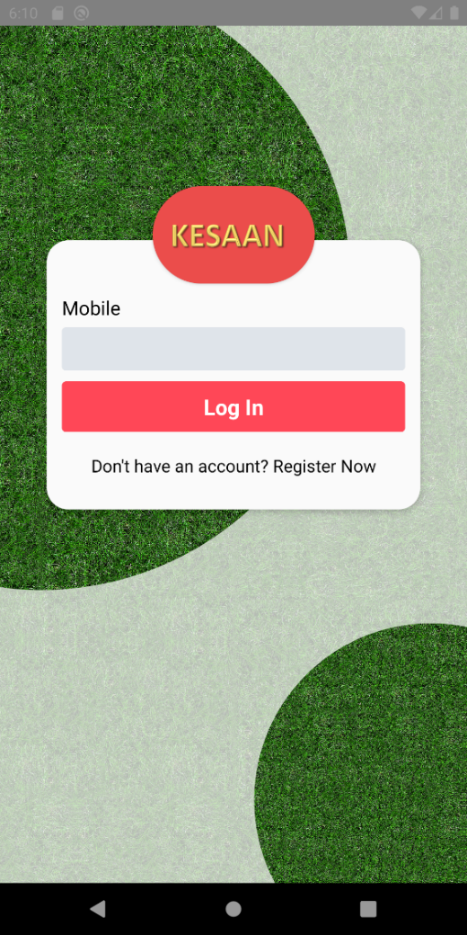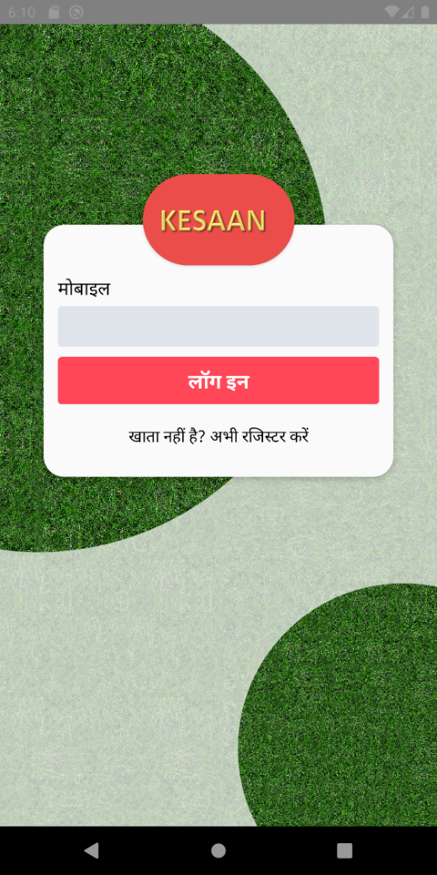

**Log In Screen in Hindi**

**Log In Screen in English**

## Home Screen

After successful registration or log in, user will be directed to the home screen. Home screen contains the weather forecast of user’s location for that day. It can be accessed from the bottom bar or from the sidebar.

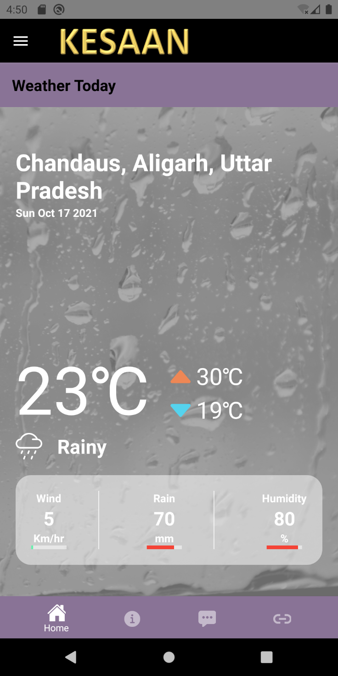

User’s location is available at the top of the page. Below the location is the date of weather forecast.

The number in the middle of the page (here, 23 $℃$) represents the temperature for that day. The number corresponding to the upward pointing red triangle is the maximum predicted temperature (in $℃$) for that day, whereas the number corresponding to the downward pointing blue triangle is the minimum predicted temperature (in $℃$) for that day.

Below the temperature is the expected weather for that day.

The three blocks at the bottom of the screen represent the wind speed (in km/hr), rain (in mm) and humidity (in %).

When the weather forecast for a particular date or for a particular location is not available, nothing is displayed in place of the values of predicted data. Only the user’s location is visible.

In case of loading or any network issue, the location is not visible as well.

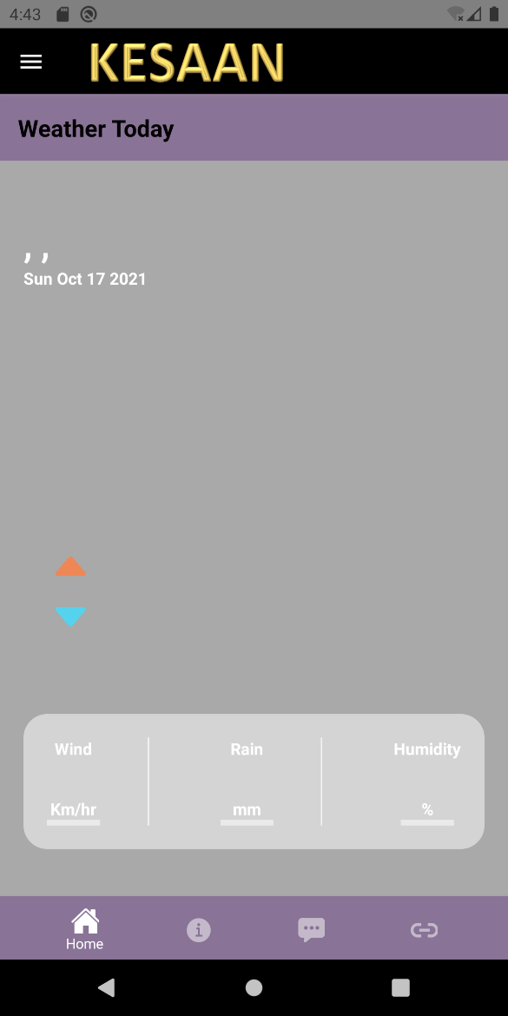 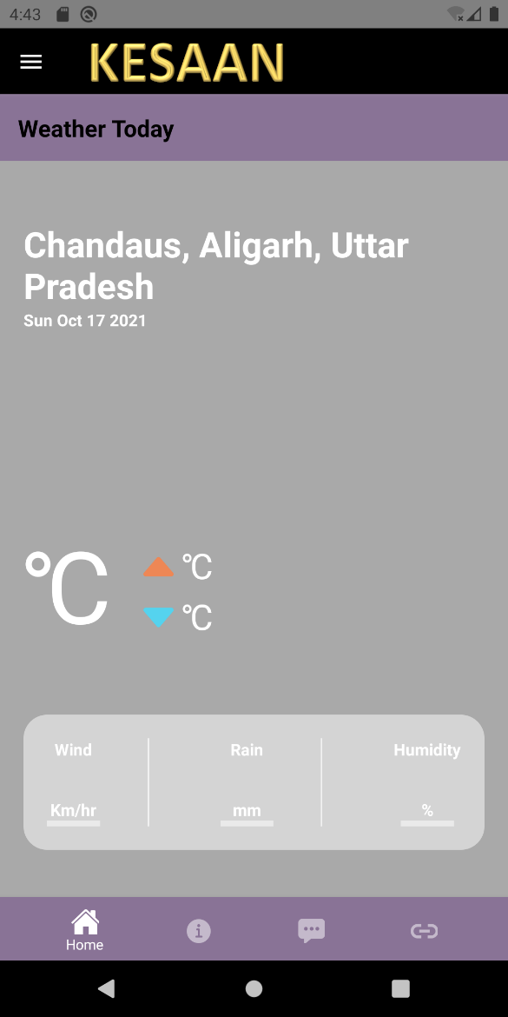

**Snapshot of a loaded screen (Weather Forecast not available for Chandaus Block on 17/10/2021)**

**Snapshot of an unloaded screen (Network issue)**

## Bottom Tabs for Navigation

Tabs are present at the bottom of the screen for navigating between the four screens:

* Home Screen

This can be accessed from the first tab of the bottom bar. It contains the weather forecast.

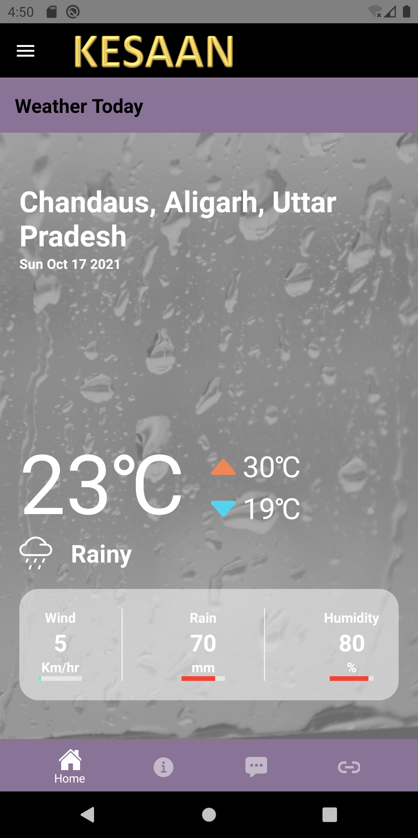

* Advisory Screen

This can be accessed from the second tab of the bottom bar. It contains the advisory for crops and weather.

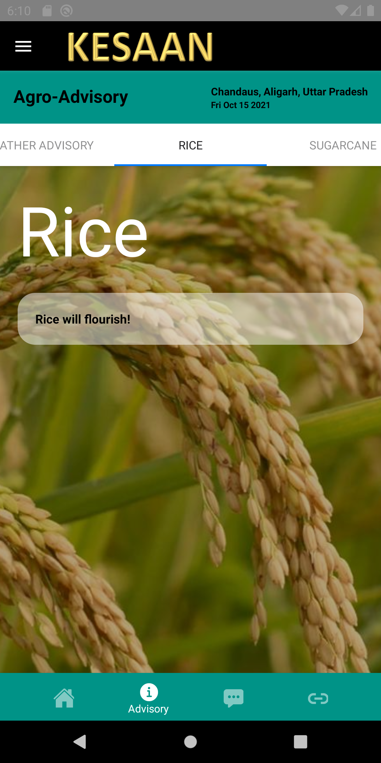

* Feedback Form

This can be accessed from the third tab of the bottom bar. It contains the feedback form.

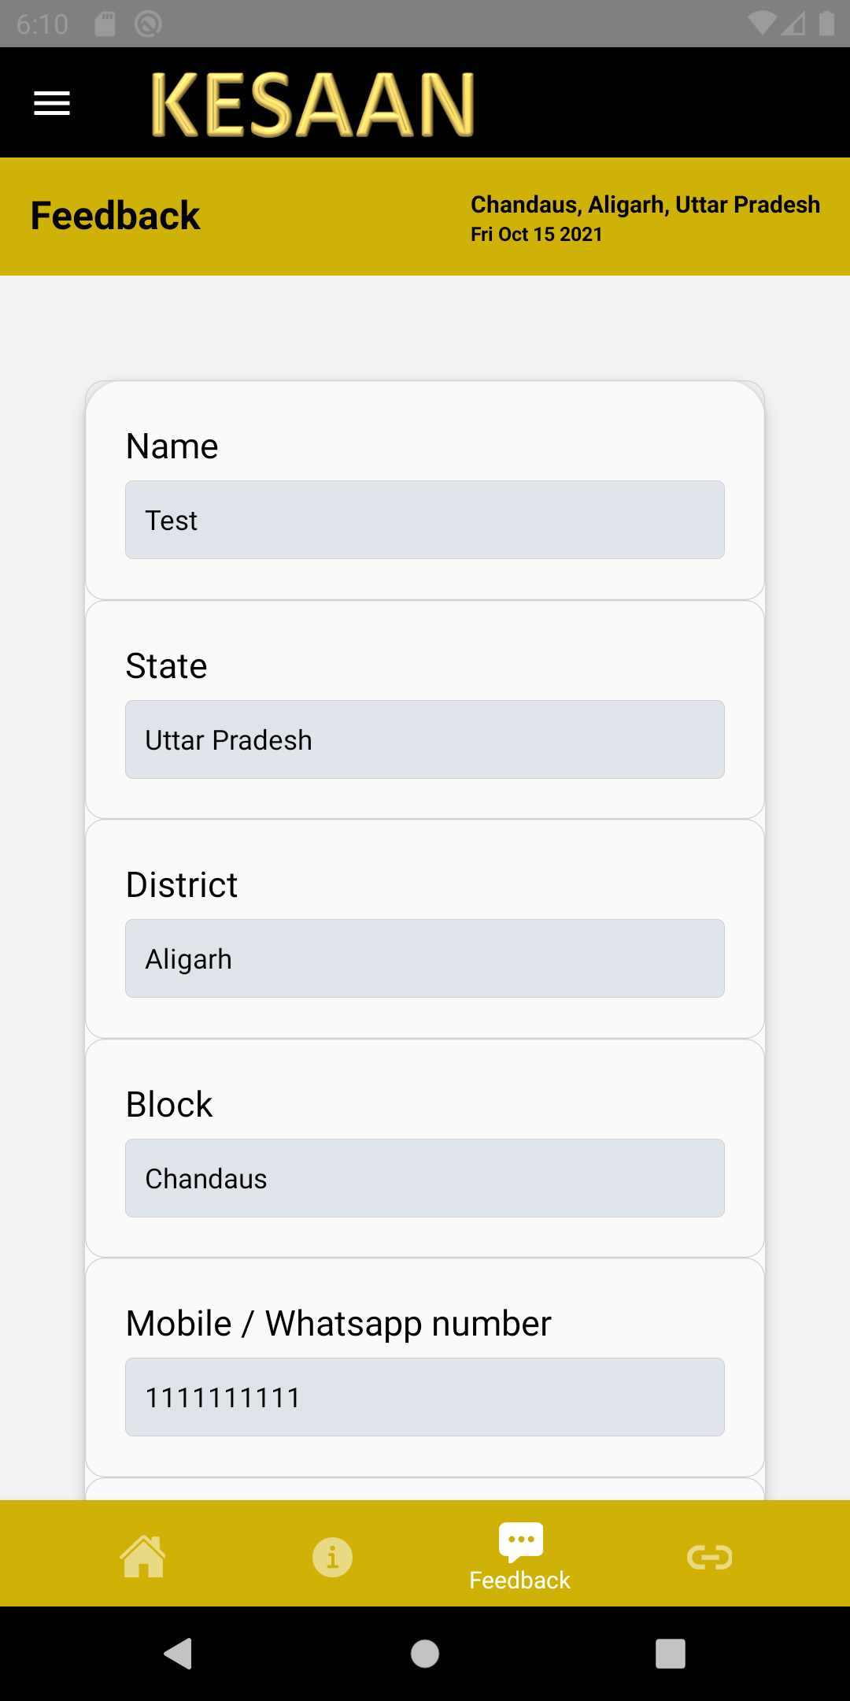

* Links Screen

This can be accessed from the fourth tab of the bottom bar. It contains useful links related to farming.

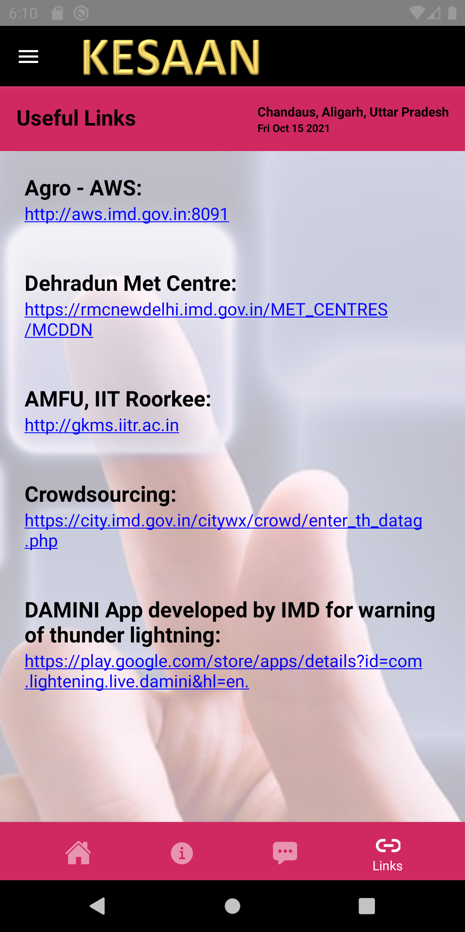

## Advisory Screen

Advisory Screen contains the advisory for weather, rice, fodder, sugarcane, vegetables, cattle, and a general advisory for that date, based on user’s location. The screen contains a scrollable top bar, each of which contains the respective advisory. It can be accessed from the bottom bar.

In case advisory in user’s preferred language is not available, then the advisory in the other language is displayed, if that’s available. If advisory is not available in any language, then that tab is not available in the top bar.

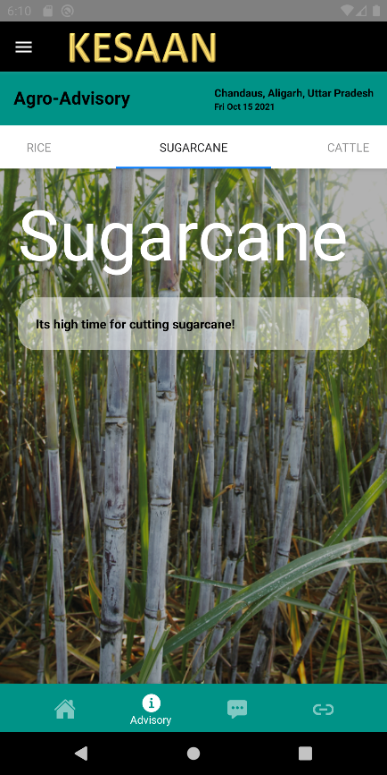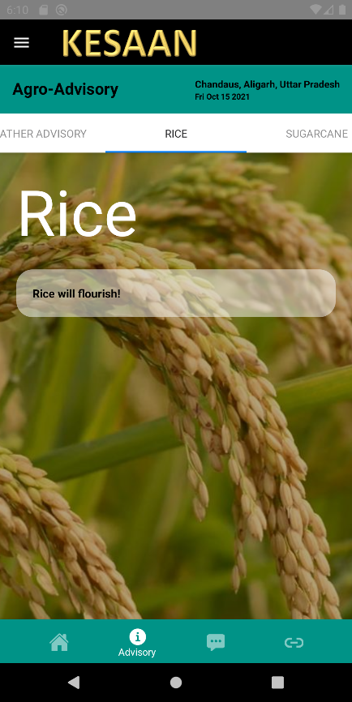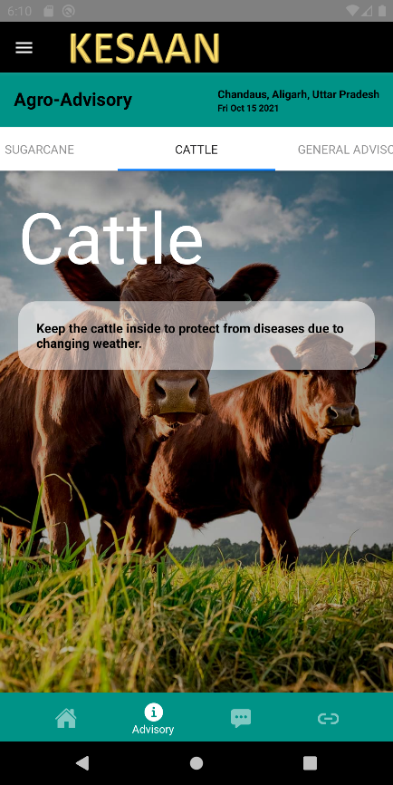

Demo screens are shown above. Advisory for weather, rice, sugarcane, cattle and general advisory are available in user’s preferred language (here English), whereas advisory for fodder and vegetables is not available in any of the languages.

If no advisory is available, then a blank screen is displayed corresponding to all the top tabs.

This can be differentiated from an unloaded page by seeing the location in the header. In an unloaded page, no location is displayed. This can be due to network issues. Try reloading the page or checking the internet connectivity.

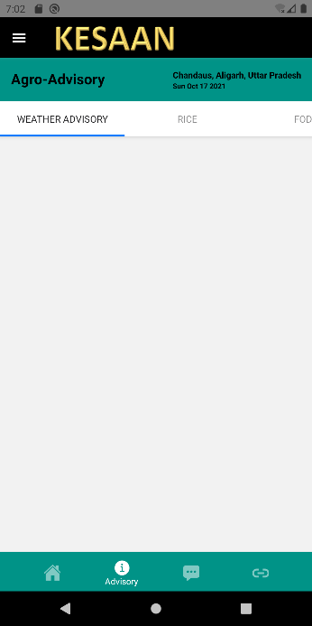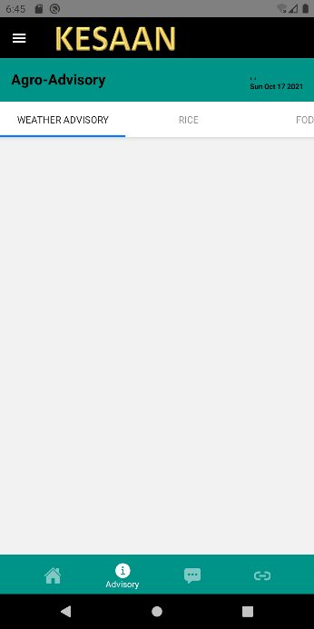

**No advisory available for Chandaus on 17/10/2021**

**An unloaded page**

## Feedback Form

The Feedback Form can be accessed from the bottom bar. It contains questions about utility of the app for further improvement.

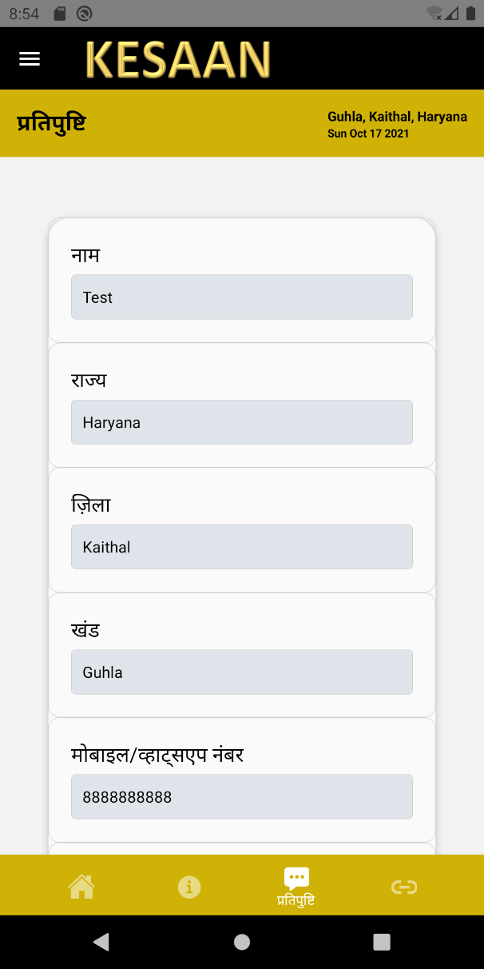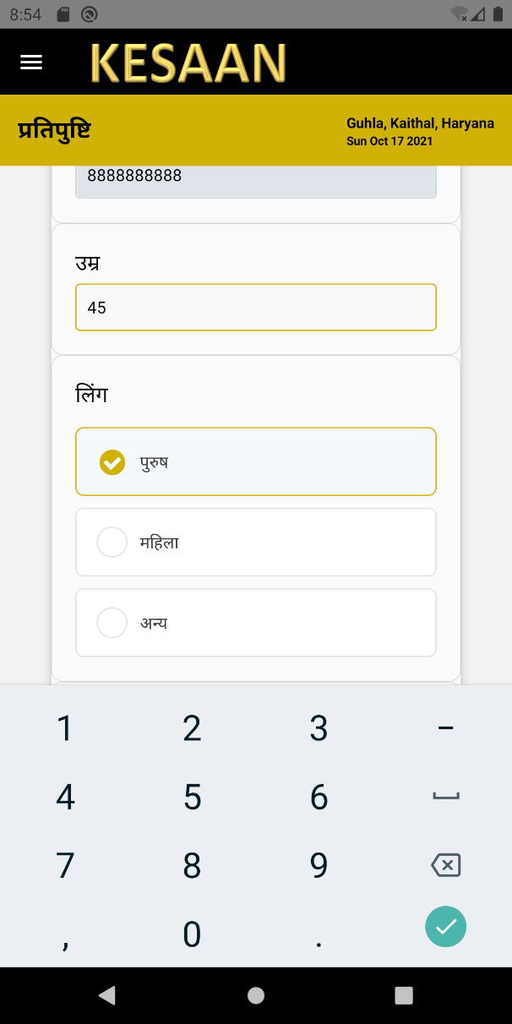

The questions containing radio buttons (circles) as options can have only one answer.

The answer to questions having blank boxes need to be typed in.

The fields – name, state, district, block, and mobile number are fixed and cannot be changed.

These details are taken from the user at the time of registration.

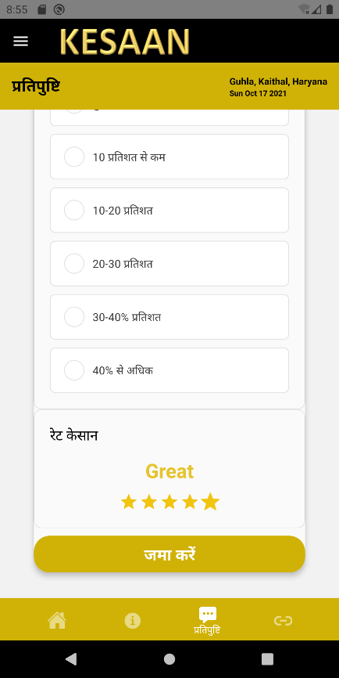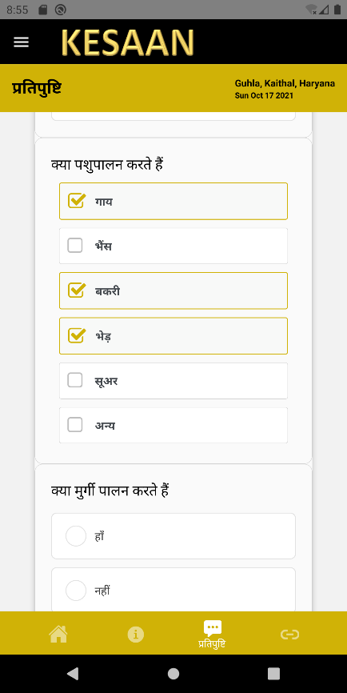

The questions having checkboxes (square box) as the options may have more than one options as the answer.

The ratings can have five values – 1 (Terrible), 2 (Bad), 3 (Okay), 4 (Good), and 5 (Great) – where 1 is the lowest and 5 is the highest.

After completing the entire form, it may be submitted. If answer to any of the fields is missing, a warning will be displayed and the form will not be submitted.

## Links Screen

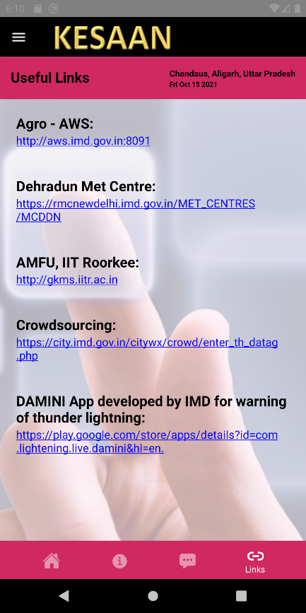

It contains some useful links related to resources that provide agriculture related advisory and data. It can be accessed from the bottom bar.

## Sidebar Navigation

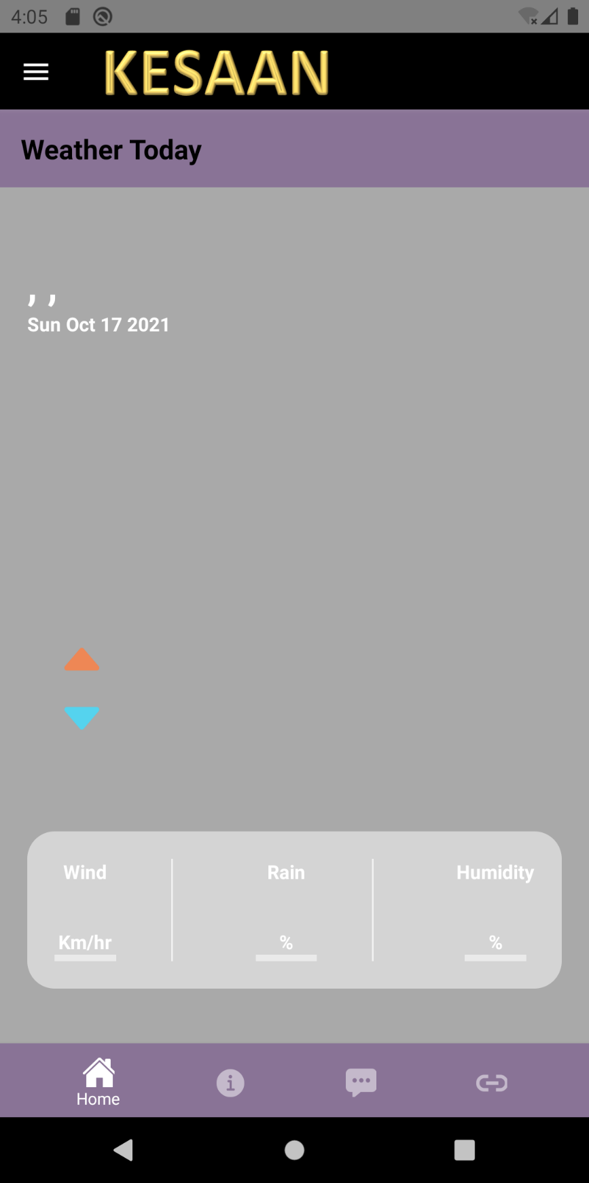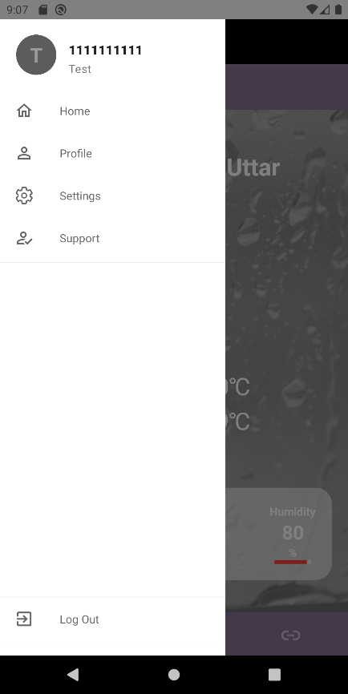

The Sidebar menu can be used to access the profile, settings and support screen. At the bottom section is the Log Out button.

The drawer / sidebar can be opened from the three lines present at the top in the header, near the app’s logo.

## Profile

The profile may be viewed from the Profile Tab in the sidebar. It contains all the information of the user, entered at the time of registration.

*The profile can only be viewed and it cannot be changed.*

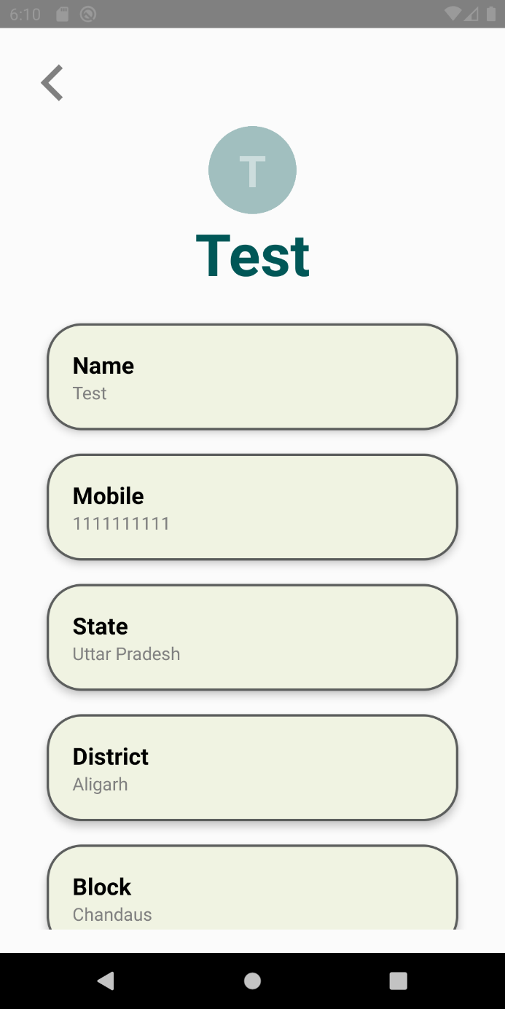

# Definitions and Acronyms

|  |  |
| --- | --- |
| **Abbreviation** | **Description** |
| SDD | Software Design Document |
| DFD | Data Flow Diagram |
| KISAN | KISAN Empowerment through Satellite-based Agricultural Advisory and Nowcast |
| NPM | Node Package Manager |
| JDK | Java Development Kit |
| CLI | Command Line Interface |
| SQL | Structured Query Language |
| PHP | PHP Hypertext Preprocessor |
| HTTP | Hypertext Transfer Protocol |
| XAMPP | XAMPP Apache + MariaDB + PHP + Perl |
| IDE | Integrated Development Environment |
| CGI | Common Gateway Interface |
| RDBMS | Relational Database Management System |
| GUI | Graphical User Interface |
| NA | Not Applicable |

# References

[1] [React Native official website](https://reactnative.dev/)

[2] [Node.js official webpage](https://nodejs.org/en/)

[3] [JDK official webpage](https://openjdk.java.net/projects/jdk8/)

[4] [Android Studio official webpage](https://developer.android.com/studio/)

[5] [PostgreSQL official webpage](https://www.postgresql.org/)

[6] [PHP official webpage](https://www.php.net/)

[7] [XAMPP official webpage](https://www.apachefriends.org/download.html)

[8] [phppgAdmin github repo](https://github.com/phppgadmin/phppgadmin)